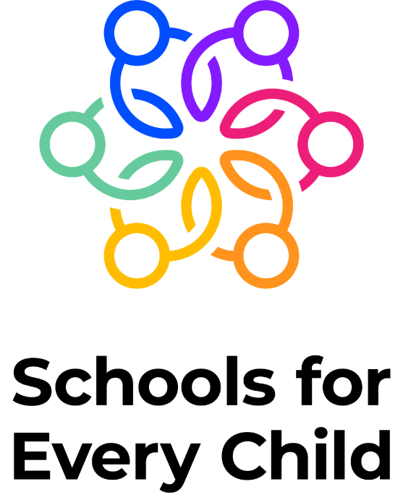

Shared Moral rooting- The driving force that gives ethical and moral validity to the organisation. A higher purpose that can be relied upon to drive the organisation. A rooting is long lasting and outlives the wishes of one individual or another.
- UNICEF rights of child

Shared Values- Actions and things we do day to day; we live our values to get to our vision:

- Altruistic- Doing good things whenever, however and to whoever you can
- Pioneering- striving to discover new things and exceed expectations
- Ethical- Making conscious decisions to be kind and fair

Shared Vision- an aspiration for the future. This holds the different parts of the organisation together. The shared vision is something each part works towards, in its own way. Specific enough that it stands you apart from others in the same field.

- Nurturing Brilliance, Guiding Exploration, Cultivating Respect- a committed journey to put every learner’s individuality, curiosity, and dignity at the forefront of the world that awaits.

Assessment Policy
Rayleigh Primary School is a Rights Respecting School. Our policies are underpinned by the UNCRC.
UNICEF Article 28(right to an education)
- Every child has a right to an education. Children’s human dignity. Wealthy countries must help poorer countries achieve this. Article 29( goals of education)Education must develop every child’s personality, talents and abilities to the full. It must encourage the child’s respect for human rights, as well as respect for their parents, their own and other cultures, and the environment.

Date Policy Created: | Spring 24
Reviewed: | Summer 25

Equality and Inclusion
At Rayleigh Primary School, we are committed to ensuring equality of education and opportunity for all pupils, staff, parents and carers; irrespective of age, race, gender, disability, faith or religion, attainment or socio-economic background. We aim to develop a culture of inclusion and diversity in which all those connected to the school feel proud of their identity and able to participate fully in school life.
The achievement of all pupils is constantly monitored; we use this data to support pupils, raise standards and ensure inclusive teaching. We will tackle discrimination by the positive promotion of equality, challenging bullying and stereotypes and creating an environment, which promotes British values; championing respect for all.
We believe that diversity is a strength, which should be respected and celebrated by all those who learn, teach and visit here. As an educationally inclusive school the teaching and learning, achievements, attitudes and well-being of every young person matters.
Our Mission Statement for Equality:
As a school,
- We welcome our duties under the Equality Act 2010 to eliminate discrimination, advance equality of opportunity and foster good relations in relation to age, disability, ethnicity, gender (including issues of transgender, and of maternity and pregnancy), religion and belief, and sexual identity.
- We welcome our duty to promote community cohesion.
- We recognise these duties reflect international human rights as expressed in the UN Convention - The Rights of the Child.
Aims and Principles

- Assessment is an integral part of teaching, based on best practice, focusing on the curriculum and that it lies at the heart of promoting children’s education.
- High quality, in depth teaching, is supported and informed by high quality formative assessment (ongoing assessment).
- There is always a clear purpose for assessing and assessment is fit for its intended purpose.
- Assessment is used to focus on monitoring and supporting children’s progress, attainment and wider outcomes.
- Assessment provides information which is clear, reliable and free from bias and informs teaching and learning.
- Assessment supports informative and productive conversations with pupils and parents.
- Children take responsibility for achievements and are encouraged to reflect on their own progress, understand their strengths and identify what they need to do to improve.
- We achieve our assessment without adding unnecessarily to teacher workload.
- Assessment is inclusive of all abilities.
- A range of assessments are used including ‘Day to Day, in-School Formative Assessment’, ‘In School Summative Assessment’ and ‘Nationally Standardised Summative Assessment’.

Delivery

At Rayleigh Primary School, we use three broad overarching forms of assessment: ‘Day to Day, in- School Formative Assessment’, ‘In-School Summative Assessment’ and ‘Nationally Standardised Summative Assessments’.

‘Ongoing Formative Assessment for Learning (AfL)’

‘Day to Day, in-School Formative Assessment’ is an integral part of teaching and learning. It helps children to measure their own strengths and areas for development. It allows teachers to understand pupil performance on a continuing basis, enabling them to identify when pupils are needing support, when they have consolidated learning and when they are ready to progress. In this way, it supports teachers to provide appropriate scaffolding (corrective activities) or mastery (enrichment activities to deepen understanding) as necessary and informs progress. It enables teachers to evaluate their own teaching of particular topics or concepts and to plan future lessons accordingly.

Through ‘Day-to Day In-School Formative AfL’ we will:

- support children in measuring their knowledge, skills and understanding against learning objectives and success criteria, identifying the next steps in their learning;
- ensure that problems are identified at the individual level and that every child will be appropriately supported to make progress and meet age related expectations;
- use assessment information to inform the planning of future learning;

A range of ‘Day-to-Day In-School Formative Assessments’, will be used including, for example:

- making use of in-depth questions and answers (Talking to Learn);
- marking of pupils’ work, particularly identifying areas of success and next steps for development;
- observational assessments, including photographic/video evidence gathering;
- regular short recap quizzes;
- discussions with children about their learning including specific verbal feedback against success criteria;
- pupil self-assessment against learning objectives and success criteria;
- peer assessment against learning objectives and success criteria;
- reference to pupil’s reading targets
- Using computer-based activities that generate assessment feedback e.g. TTRockstars for maths and Spag.com for English.
- pre-teach sessions

‘In-School Summative Assessment’

‘In-school summative assessments’ take the form of periodic teacher assessments, that provide a broader view of the pupils’ attainment and progress over a period of time (each half-term). Teachers will assess the pupils against statements of expected achievement for their age-group using the assessment programme, Sonar. Achievement against these statements will then inform a Step assessment within the age-related Bands within which the pupils should be working. Teachers participate in regular moderation activities to ensure consistency in reaching the assessment judgements, this is both within our school and with schools across the local area. The Leadership Team is responsible for overseeing the moderation of teacher assessments and ensuring consistency in practice, whilst the Assessment Leader has overall responsibility for the final assessment data.

In addition to teacher assessment, however less frequently (usually once a term), pupils will sit more formal ‘assessments’. This provides the children with valuable experience of the test process in readiness for statutory testing, as well as giving teachers a ‘snapshot’ view of attainment in a test situation. These tests do not form the basis of the overall teacher assessment judgement, but are one piece of a wide range of evidence that will be used to inform this and as a tool to identify gaps.

Teachers will make use of ‘in-school summative assessments’ to evaluate both pupil learning at the end of an instructional unit or period (based on pupil-level outcomes) and the impact of their own teaching (based on class-level outcomes). Both these purposes will support teachers in planning for subsequent teaching and learning. ‘In-school summative assessments’ will also be used at the whole school level to monitor the performance of pupil cohorts and key groups, to identify where interventions may be required and to work with teachers to ensure pupils are supported to achieve sufficient progress and expected attainment.

Parents are regularly updated throughout the year of their children’s achievements through Parent Partnership Meetings with teachers and written school reports. Pupil targets are shared and parents can see the expectations for their children’s age-group. The school operates an open-door policy all year round, so parents can discuss their children’s achievement at any point throughout the year with the class teacher. In addition, we use a communication book that can be used between the parent and the teacher to ensure there is effective dialogue and all parties are kept updated.

Ranges of ‘In-school-summative assessments’ are being used including, for example:
- Weekly spellings and monthly multiplication/division super hero tests
- Termly ‘best fit’ assessment against National Curriculum expectations using Sonar (used to inform pupil progress meetings)
- Teachers use end of unit assessments in Maths and record the scores centrally
- End of term/year tests in the form of NFER assessments (KS1 use the national SATS papers in Summer Term- we use the data internally only)
- ASI meetings for pupils with SEND
- End of year annual report to parents outlining progress and attainment of children in relation to National Curriculum age related expectations.

National Standardised Summative Assessment

Nationally standardised assessments will be used to provide information on how children are performing in comparison to children nationally. They will provide parents with information on how the school is performing in comparison to schools nationally. Teachers will have a clear understanding of national expectations and assess their own performance in the broader national context. Nationally standardised summative assessment enables the school leadership team to benchmark the school’s performance against other schools locally and nationally, and make judgements about the school’s effectiveness. The government and OFSTED will also make use of nationally standardised summative assessment to provide a starting point for Ofsted’s discussions, when making judgements about the school’s performance.

A range of ‘Nationally standardised summative assessments’ will be used:

- A Baseline Assessment on entry into Reception age 4
- A Phonics test in Year 1
- National Curriculum MTC testing in Year 4
- National Curriculum tests at the end of Key Stage 2

An Inclusive Approach to Assessment

In addition to the assessments above, the school will make use of additional diagnostic assessments to contribute to the early and accurate identification of children and young people’s special education needs and any requirements for support and intervention.

Training for Staff

After joining the school, all teachers will be provided with a copy of this policy and it will form part of the induction programme. In further CPD, there will be an emphasis on teachers having a good understanding of assessment and assessment practice.

The school makes significant use of technology to assess and in order to support staff, training in the use of Sonar will be given to all new teaching staff and regular updates will be given throughout the year.

Continuing professional development may take various forms including the provision of direct face to face training and online training. The Assessment Leader will ensure that best practice is shared and endeavour to keep up to date with latest research. The school, in making use of external assessment systems, will continually review and evaluate them to ensure that they support the delivery of the school’s assessment policy and are in line with the aims and principles outlined.

Monitoring and Evaluation

The Assessment Leader is responsible for updating this policy in line with any new developments in the school and new government guidance. All staff are expected to follow the policy and the Leadership Team, following ongoing regular reviews of classroom practice, will be responsible for ensuring the effectiveness of practice across the school, reporting to the Governing Body.

SLT meet with the class teacher to carry out Pupil Progress meetings to track the progress of children’s learning and implement strategies to support them – at whatever stage in their learning they may be.

This policy is written in line with all subject based policies, Early Years Policy and the Marking Policy.

