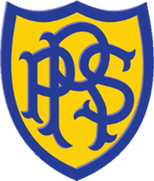

Rayleigh Primary School uniform
Uniform items | Examples | Notes
Royal blue sweatshirt, jumper or cardigan for Reception and above  Yellow sweatshirt for Nursery | 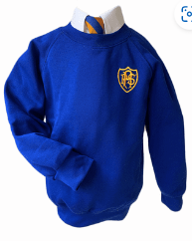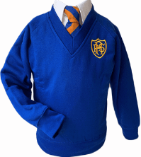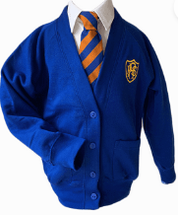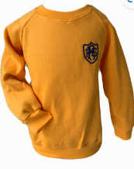 | Pupils should have at least one branded sweatshirt or cardigan but may have others non-branded.
White shirt or polo shirt (white or royal blue for Reception-Y6 and yellow polo shirt for Nursery) | 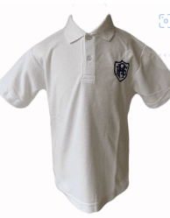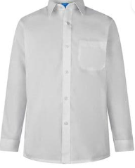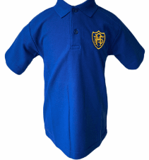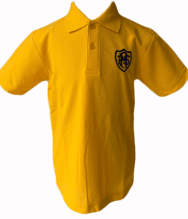 | Branded or non-branded
Tie with shirt (royal blue and gold) | 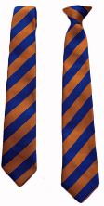 | Optional but expected for some external performances (eg Music Festival)
Grey trousers, skirt, pinafore or shorts | 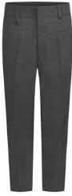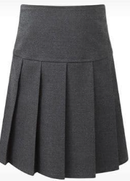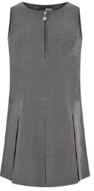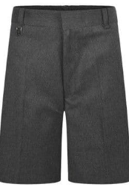 | Non-branded
Sky blue checked summer dress | 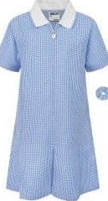 | Non-branded
Closed, plain black sensible shoes - short boots may be worn in winter.  No shoes should be worn which are not fully secured to your child’s feet (no flip-flops due to health and safety reasons) | Acceptable  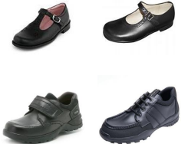  Not acceptable  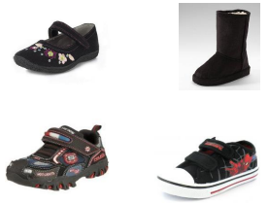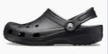 | Non-branded
White, black or grey socks or tights |  | Non-branded
PE - yellow t-shirt | 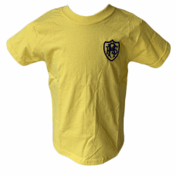 | Branded or non-branded.  Your child should wear their PE kit to school on PE day and stay in it for the whole day.
PE - royal blue hoodie OPTIONAL | 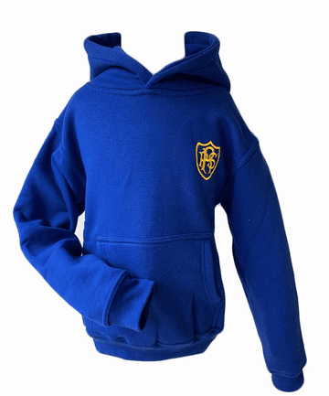
PE - Sports trainers (not fashion trainers) Ideally these should be black. | 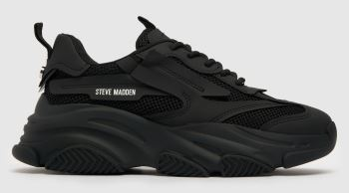 | Your child should wear their PE kit to school on PE day and stay in it for the whole day.
PE - Royal blue, dark blue, or black shorts, jogging bottoms or leggings | 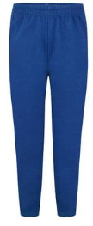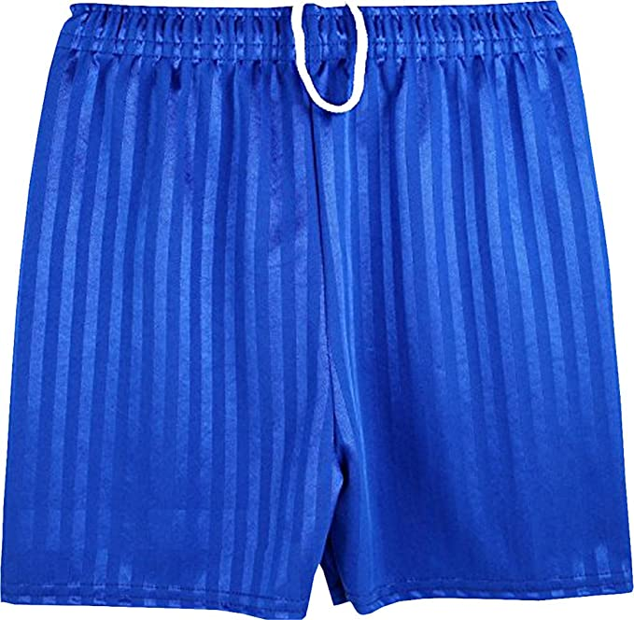
Hair | Only small and discreet hair accessories may be worn. All long hair should be tied up for Health and Safety reasons in PE.
Jewellery | The only jewellery permitted are watches, one pair of small stud earrings and items worn for religious purposes. When considering ear piercing please use the start of the summer holidays to allow healing time. All jewellery must be removed for sport. A waiver form may be signed to keep earrings in. This form is on the website in the uniform section.
Swimwear | Swimwear must be modest and swimming hats must be worn. Hats can be purchased from the school in the child’s house colour.
School coats | We advise reflective safety strips to be attached to coats.
Our branded school uniform is sold in Danielles and the price list is on our website. All pupils should have at least one sweatshirt or jumper with the school logo on it but the remainder of the uniform, as long as it is the correct colour, may be bought from other stockists.
Our PTA sells pre-loved uniforms. Please contact the school office for more information.
Pupils are expected to wear the correct uniform at all times (other than specified non-school uniform days) while:
- On the school premises
- Travelling to and from school
- At out-of-school events or on trips that are organised by the school, or where they are representing the school (if required).

PE kit should be worn on PE days.
We value diversity and inclusivity. Please contact the school office (schooloffice@rayleighprimary.org.uk) if you wish to discuss uniform in relation to protected characteristics.

